Ex.No.4: OFDMA Resource Block Allocation
Date:30/7/2026

AIM:
To simulate and analyze OFDMA (Orthogonal Frequency Division Multiple Access)
resource block allocation and evaluate system performance in terms of resource utilization and
user throughput using MATLAB.

Objective
1. To determine the Number of Resource Blocks (RBs) allocated in an OFDMA system
based on available bandwidth and system configuration.
2.
To evaluate the Resource Block Utilization (%) by analyzing how efficiently available
RBs are assigned to active users.
3.
To calculate the User Throughput (Mbps) based on allocated resource blocks and
modulation efficiency in the OFDMA system.
Procedure
1. Define the system bandwidth and calculate the number of available resource blocks
(RBs) based on RB size (e.g., 180 kHz per RB).
2. Identify the number of active users in the OFDMA system for resource sharing.
3. Allocate resource blocks to each user based on a predefined or equal distribution
strategy.
4. Compute Resource Block Utilization (%) using the ratio of allocated RBs to total RBs.
5. Assign modulation efficiency values (e.g., QPSK, 16-QAM, 64-QAM) for each user.
6. Calculate User Throughput (Mbps) using allocated RBs and modulation efficiency.
7. Plot graphs for RB allocation and utilization/throughput analysis using MATLAB.
8. Analyze results to evaluate spectrum efficiency and system performance.

Objective 1 Matlab Code and Output:
clc; clear; close all;
% System parameters
bandwidth = 10e6; % 10 MHz
rb_size = 180e3; % 180 kHz per RB
% Total Resource Blocks
total_RB = floor(bandwidth / rb_size);
% Users
users = 1:6;
% RB allocation (simple equal + remainder distribution)
base = floor(total_RB / length(users));

alloc = base * ones(1,length(users));
alloc(1:mod(total_RB,length(users))) = alloc(1:mod(total_RB,length(users))) + 1;
utilization = (alloc / total_RB) * 100;
disp('Total Resource Blocks:')
disp(total_RB)
disp('RB Allocation per User:')
disp(alloc)
figure
% -------- Graph 1: RB Allocation per User --------
subplot(2,1,1)
stem(users, alloc, 'filled', 'LineWidth', 2)
title('OFDMA Resource Block Allocation per User')
xlabel('User Index')
ylabel('Number of Resource Blocks')
grid on
% -------- Graph 2: RB Utilization --------
subplot(2,1,2)
plot(users, utilization, '-o', 'LineWidth', 2)
title('OFDMA Resource Block Utilization (%)')
xlabel('User Index')
ylabel('Utilization (%)')
grid on
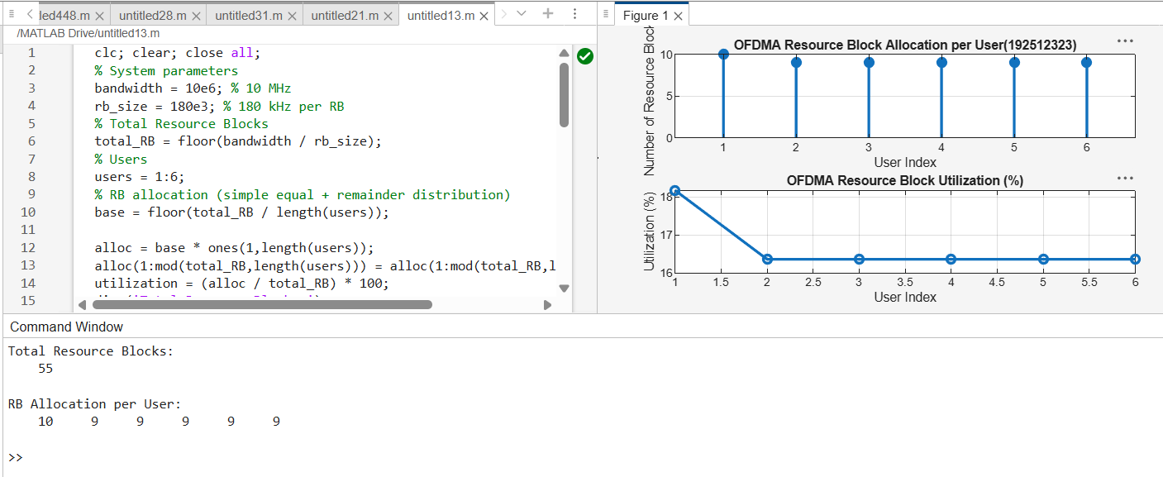

The first graph shows how available resource blocks are distributed among multiple users in the
OFDMA system.
The second graph represents utilization efficiency, indicating how effectively the spectrum is
shared among users.

Objective 2 Matlab Code and Output:
clc; clear; close all;
% Total system resource blocks
total_RB = 50;
% Number of active users
users = 1:5;
% RB allocation to users (example scenario)
alloc = [12 10 9 8 11];
% Resource Block Utilization (%)
util = (alloc / total_RB) * 100;
disp('Resource Block Utilization (%) per User:')
disp(util')
figure
% -------- Graph 1: RB Allocation --------
subplot(2,1,1)
plot(users, alloc, '-o', 'LineWidth', 2)
title('OFDMA Resource Block Allocation per User')
xlabel('User Index')
ylabel('Number of Resource Blocks')
grid on
% -------- Graph 2: Utilization (%) --------
subplot(2,1,2)
plot(users, util, '-s', 'LineWidth', 2)
title('OFDMA Resource Block Utilization (%)')
xlabel('User Index')
ylabel('Utilization (%)')
grid on
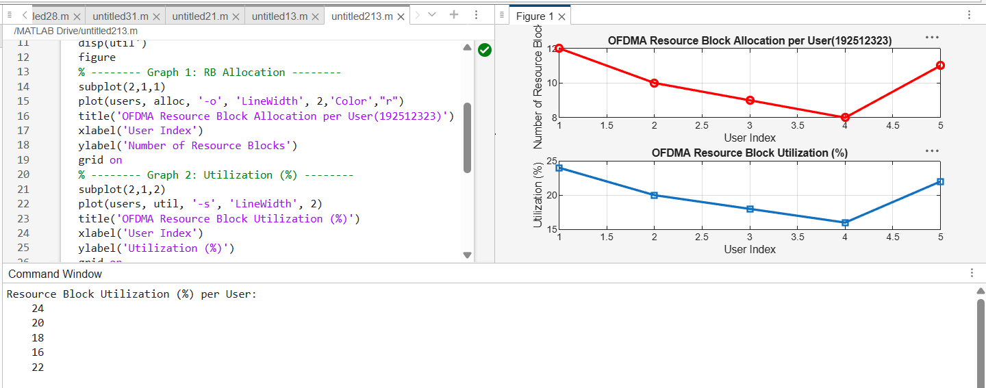
The first graph shows how resource blocks are distributed among multiple users in the OFDMA
system.
The second graph indicates the efficiency of spectrum usage by each user in terms of percentage
utilization.
Objective 3 Matlab Code and Output:
clc; clear; close all;
% System parameters
rb_bw = 180e3; % Bandwidth per RB (180 kHz)
users = 1:5;
% Allocated Resource Blocks per user
alloc_RB = [12 10 9 8 11];
% Modulation efficiency (bits/symbol)
mod_eff = [2 4 6 4 2]; % QPSK, 16QAM, 64QAM etc.
% Throughput calculation (Mbps)
throughput = (alloc_RB .* rb_bw .* mod_eff) / 1e6;
disp('User Throughput (Mbps):')
disp(throughput')
figure
% -------- Graph 1: Throughput per User --------
subplot(2,1,1)

plot(users, throughput, '-o', 'LineWidth', 2)
title('OFDMA User Throughput')
xlabel('User Index')
ylabel('Throughput (Mbps)')
grid on
% -------- Graph 2: RB vs Throughput --------
subplot(2,1,2)
plot(alloc_RB, throughput, '-s', 'LineWidth', 2)
title('Resource Blocks vs Throughput Relationship')
xlabel('Allocated Resource Blocks')
ylabel('Throughput (Mbps)')
grid on
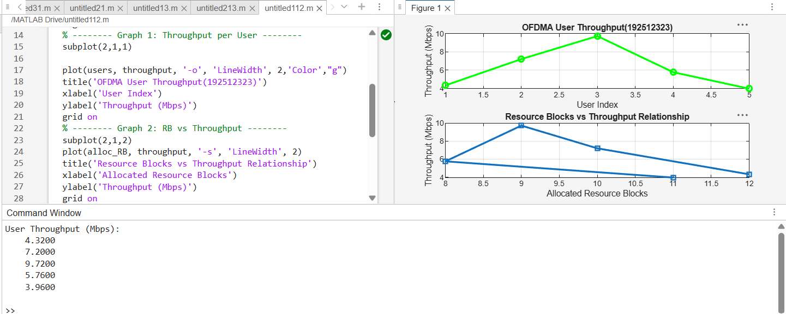
The first graph shows that user throughput increases with higher modulation efficiency and
allocated resource blocks.
The second graph clearly indicates a linear relationship between resource blocks and achieved
throughput in OFDMA systems.
Result:
1. The Resource Block (RB) allocation was successfully simulated for multiple users in the
OFDMA system, demonstrating how available spectrum is distributed among active
users.
2. The Resource Block Utilization (%) analysis showed efficient usage of system resources,
indicating how effectively the available RBs are assigned to users.

3. The User Throughput (Mbps) was successfully calculated based on RB allocation and
modulation efficiency, showing that higher allocated RBs and higher modulation
schemes result in increased throughput.

